318 Stearns Road
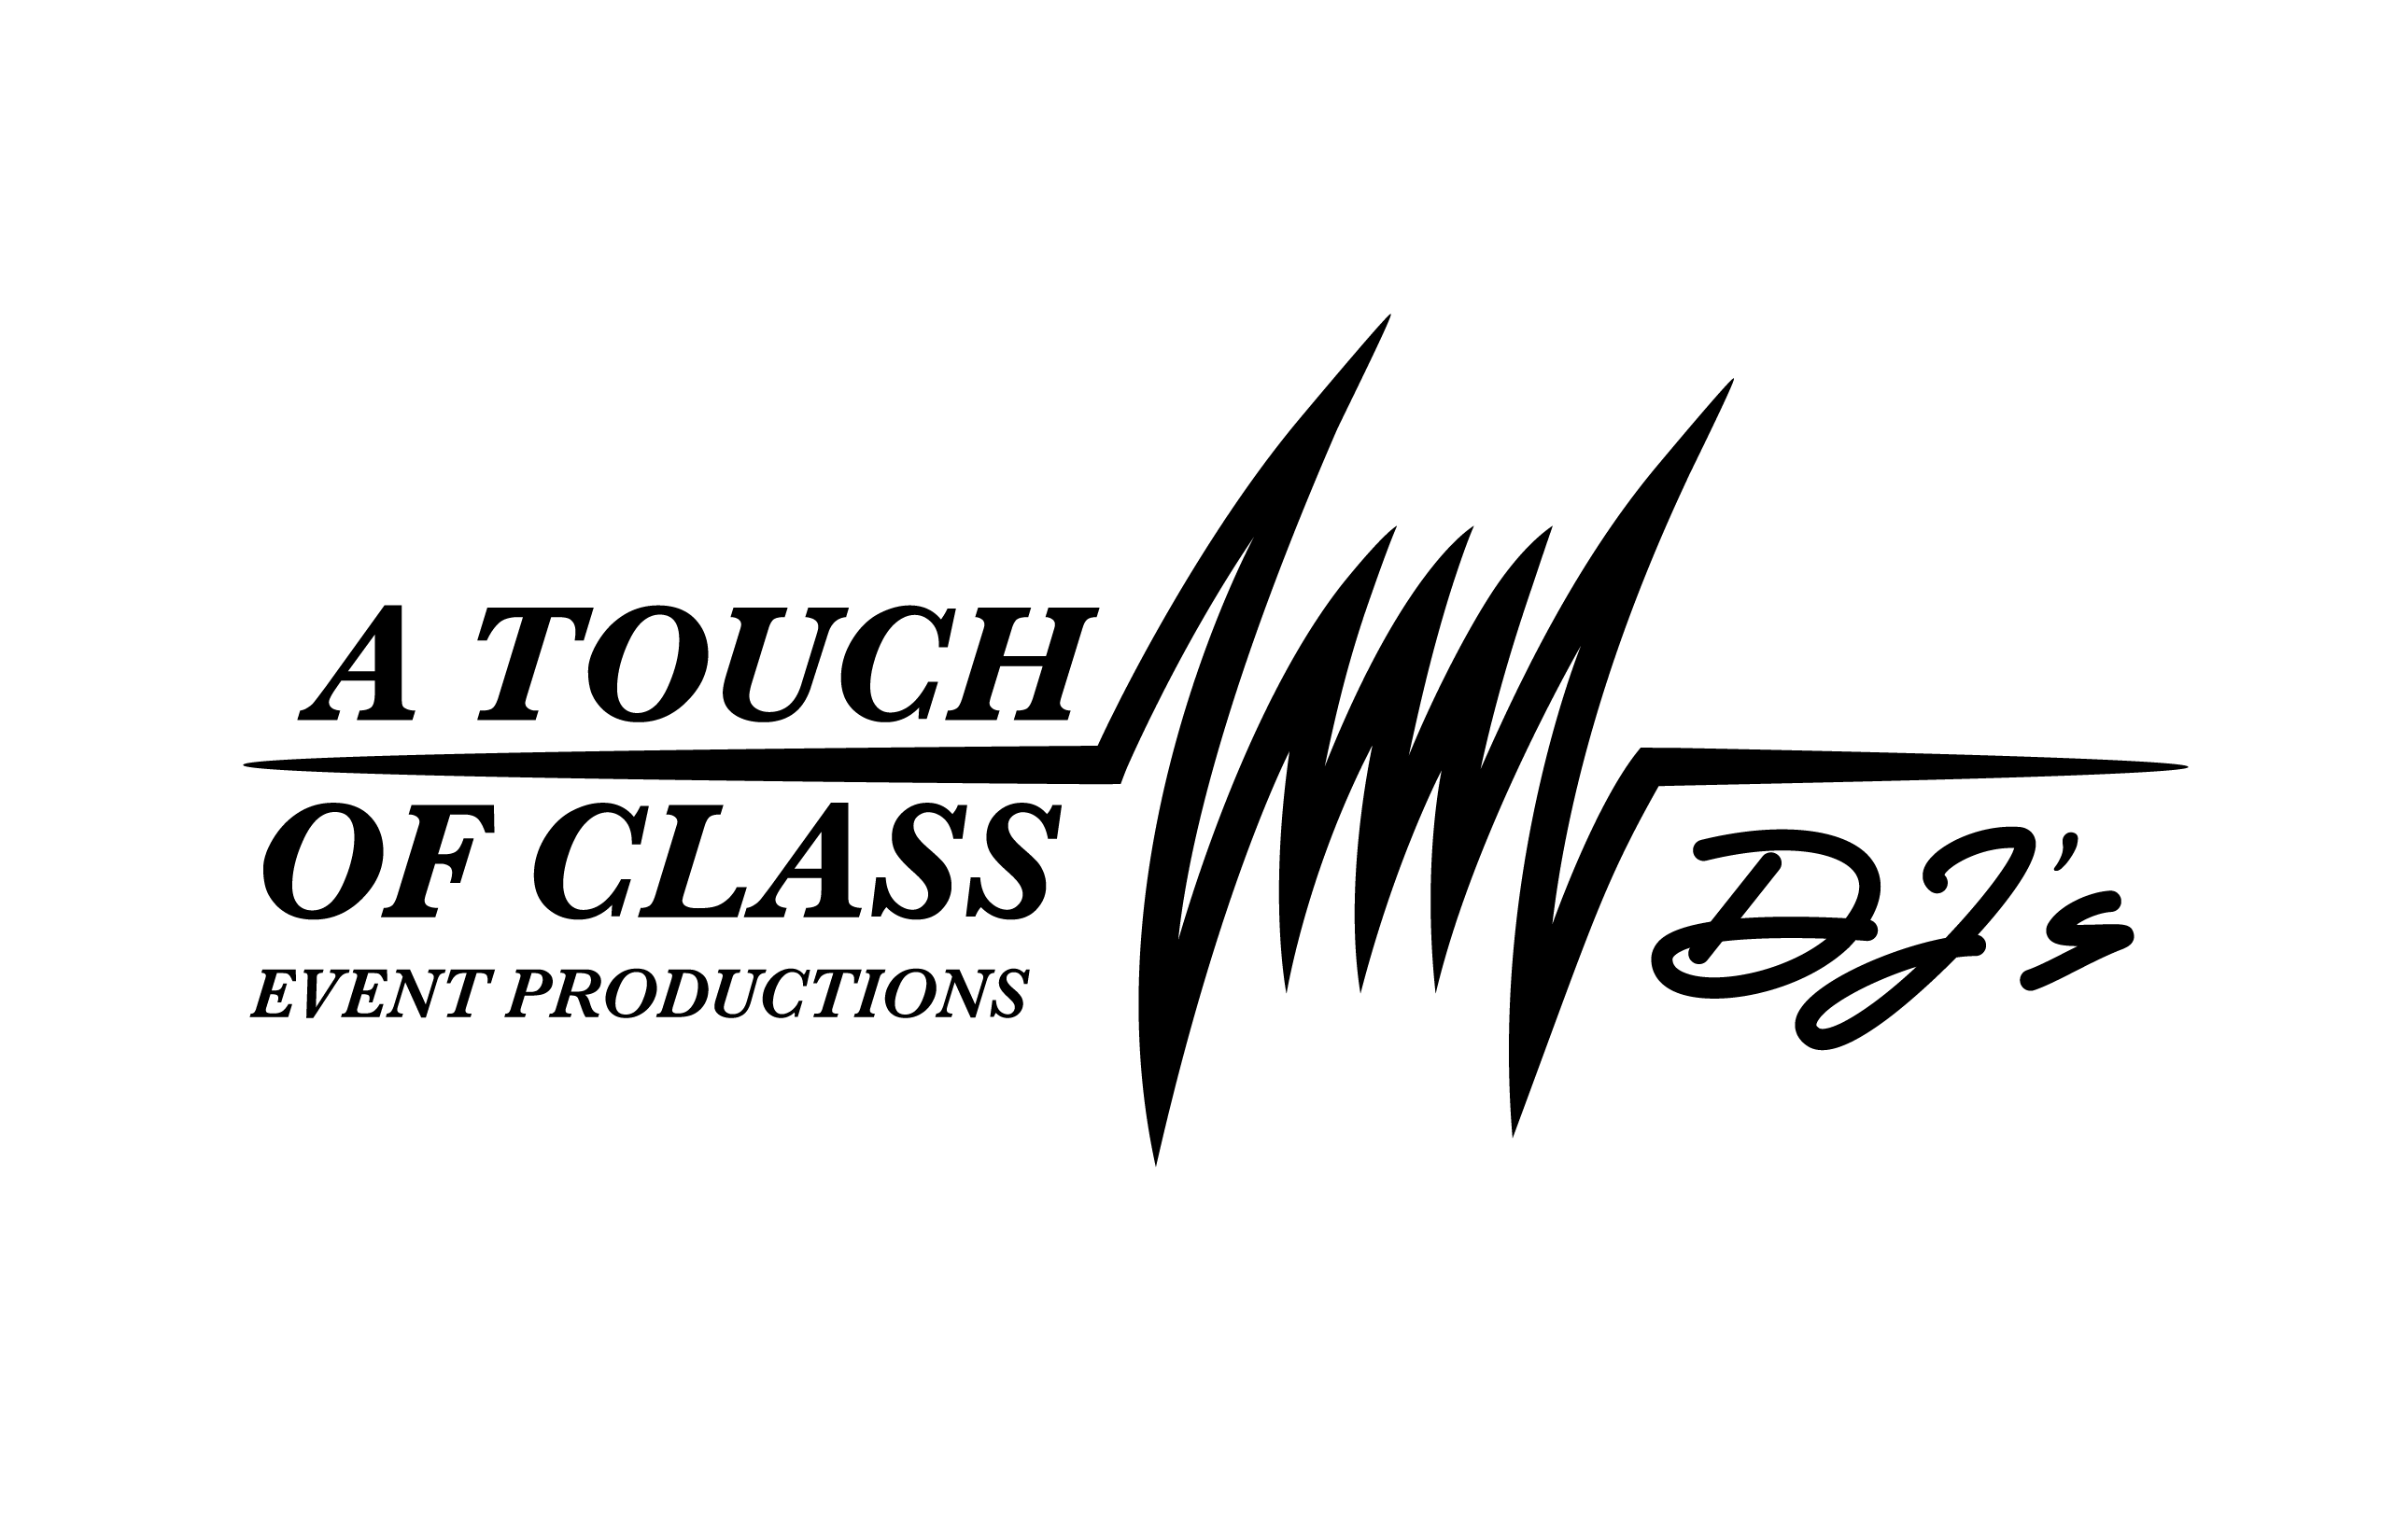
Marlborough, MA 01752
(508) 229-0009
(800) 480-3200
ATOCDJ @aol.com
www.ATouchOfClass.com
www.ATOCweddings.com
www.Facebook.com/atocdjs
Wedding Fact Sheet

Names: (Bride) (Groom)
Event Date: Time of Ceremony: Time of Reception:
Phone Number: (day) (eve)
Reception Location: Location Phone:
Venue Contact Name: Venue Contact Email Address:
Photographer Name: Photographer Email Address:
Videographer Name: Videographer Email Address:
Master of Ceremonies: Attire:
- Approximate Number of Guests:
- Will you be having a Receiving Line at the Reception? If Yes, When?

Please list the following in EXACT ORDER OF INTRODUCTION and exactly as their names are to be announced. (SPELL PHONETICALLY)

Grandparents? (Indicate Bride’s or Groom’s):
Introduced In? or From Their Seat?

Parents of Bride:

Parents of Groom:

Bridesmaids Ushers

Flower Girl Ring Bearer

Maid/Matron of Honor (please indicate) Best Man

Bride & Groom: Bride’s 1st Name:

- Name of Person to say Blessing:
- Name of Person giving Toast (if other than Best Man):
- Will Maid/Matron of Honor or anyone else be saying a few words: If so, Who?

- Will you be having a First Dance?

- Time of First Dance: After Introductions Other (specify)

- Will the entire wedding party be invited up for the First Dance?

- Song Selection:
Song Artist
- Will there be a second dance for the entire wedding party?
- Time: After First Dance Other (specify)
- Song Selection:
- Would you like crazy couples or poems/songs for kissing during dinner? Yes ___ No ___What is it?

- Will you be having a Cake Cutting Ceremony?
- Time: Before Main Course Other (specify)
- Type of Ceremony:
- Traditional with sing-a-long (The Bride Cuts The Cake)
- Background music with announcing without announcing
- Other or Song Selection
- Will the Bride dance with her Father? Will the Groom dance with his Mother?

A. Song Selection (If at the Same Time)

B. Song Selection (If Different Times) Bride’s

Groom’s
- Will you be giving the centerpieces away? Do you want your entertainer to decide how to give away?

- Will you be throwing the Bouquet?
Will you be throwing the Garter?
- Should your entertainer be: Lively and Interactive or Conservative
- Would you like to have an anniversary dance during dancing time?
Absolutely Let the Entertainer Decide No What is it?
- Will there be a Last Dance? Yes_____ No_____
- Song Selection:
- Method for Last Dance:
- Announce last dance only with everyone invited to dance
- Circle around Bride & Groom then Good-byes
- Circle Dance and then eventually invite everyone to join
- Circle for last dance with one more song following for all
Song Selection:
DJ’s selection: fast (or) slow
- Will you be changing? Yes No __
- Will food be provided for A Touch Of Class DJ’s personnel?
- Special Requests: trivia during dinner, announcements, songs you want/ do not want played, type of music or artists, etc. (Attach additional sheet if needed)

Return this questionnaire at least 2 weeks prior to your function date.
Please contact us if you have any questions or concerns.
Thank You For Choosing A Touch Of Class DJ’s!

Ceremony Music Form
If your Entertainer is performing ceremony music, please answer the following.

- Location of the ceremony?
- What time is music scheduled to start?
(We recommend 30 minutes before ceremony start time)
- What type of music would you prefer for pre-ceremony?
- Song for bridesmaids processional:
Song Title Artist
- Song for Bride processional:
Song Title Artist
- Are you having a unity candle or other break in the action during the ceremony? _____ Yes _____ No
  - If so, do you want music for this time? _____ Yes _____ No
  - Song:
Song Title Artist
- Song for recessional:
Song Title Artist

